

|  |  |
| --- | --- |
|  |  |

Waahi**Waahi**

**Deployment Guide**

**March 2020**

**Contents**

1 Setting up Web AppBuilder and Waahi for the first time 3

1.1 Download Web AppBuilder for ArcGIS (Developer Edition) SDK 3

1.2 Download and unzip the Waahi application 3

1.3 Run the deployment app 3

1.4 Troubleshooting 4

1.5 Additional setup 4

2 Upgrade Web AppBuilder to a newer version 4

2.1 Download the new version of WAB 4

2.2 Deploy Waahi to the new version of WAB 4

2.3 Migrate existing apps to the new version of WAB 5

3 Upgrade Waahi to a newer release 5

# Setting up Web AppBuilder and Waahi for the first time

* 1. Download Web AppBuilder for ArcGIS (Developer Edition) SDK

Download the version of Web AppBuilder (WAB) required and that is compatible with the latest Waahi release which aren’t normally far behind the latest version of WAB. The version for which a specific Waahi release has been tested against is in the first part of the release name, for example 2.12.x.x means it was developed and tested against version 2.12 of WAB. Find different versions of WAB ready for download at this page:

<https://developers.arcgis.com/downloads/apis-and-sdks?product=web-appbuilder>

Follow this guide to get WAB running on your machine if it hasn’t been set up already:

<https://developers.arcgis.com/web-appbuilder/guide/getstarted.htm>

* 1. Download and unzip the Waahi application

Once the WAB instance is ready, download and unzip the Waahi-WAB deployment app to a separate folder. Once the source code for the Waahi instance has been downloaded, the Waahi deployment app can be used to copy relevant files into your Web AppBuilder (WAB) instance for a typical Waahi setup.

For example, you will have the WAB folder with its contents, and the Waahi app with its contents in another folder:

WebAppBuilder-dev

|---- client

|---- docs

|---- server

Waahi-WAB

|---- deploy_app

|---- stemapp

|---- node_x64.exe

|---- node_x86.exe

|---- README.md

|---- ui.bat

* 1. Run the deployment app

Run "ui.bat". A browser should open and display the deployment console (on <http://localhost:3347/>). If you encounter issues check the port setting in the ui.bat file.

Once running:

* Use the "Existing Web AppBuilder location" input and click **set** to update the location of your relevant or new WAB install.
* Select the deployment configuration, typically this will be "Waahi".
* Use the "Deploy" button to copy relevant files.

A file watcher is also available, which monitors files in the "stemapp" source folder for changes. This is typically used during development only.

* 1. Troubleshooting

If you receive errors, check that Web AppBuilder runs by itself, before any Waahi code has been added. This will help pinpoint the problem.

Also check file permissions - Node.js needs to be able to modify files in the Web AppBuilder and Waahi-WAB directories.

* 1. Additional setup

Additional Waahi components that can be optionally installed are:

* Waahi-Services (web services) includes a .NET Core web service for the Share Plus widget, as well as Python geoprocessing services for Print and Data Export widgets.  
  [Waahi-Services repo](https://github.com/GeographicBusinessSolutions/Waahi-Services)
* Waahi-Gallery is a minimalistic landing page for your ArcGIS Enterprise or ArcGIS Online users, allowing Waahi and other deployed applications to be easily discovered.  
  [Waahi-Gallery repo](https://github.com/GeographicBusinessSolutions/Waahi-Gallery)

# Upgrade Web AppBuilder to a newer version

* 1. Download the new version of WAB

Download and unzip the new version of WAB in parallel to the previous version that was set up (don’t replace the previous version).

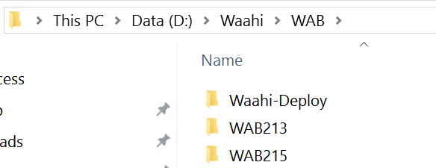

If the new WAB’s startup.bat file is run, it will ask for the portal URL and an App ID. Use the same portal and app ID that was used for the previous WAB instance. The new WAB version will still run on the same port and URL. One of these WAB instances can now run at a time by running its Startup.bat file and going to the WAB URL in the browser.

* 1. Deploy Waahi to the new version of WAB

Run the Waahi deployment app again and set the location to the new WAB instance. Waahi is now deployed to this WAB.

* 1. Migrate existing apps to the new version of WAB

Migrating existing apps from an older version of WAB to the newer version entails the following:

* + 1. Open the previous WAB instance and download the relevant apps (note that the old and new WAB cannot be running simultaneously, because they are on the same port, 3344, by default):

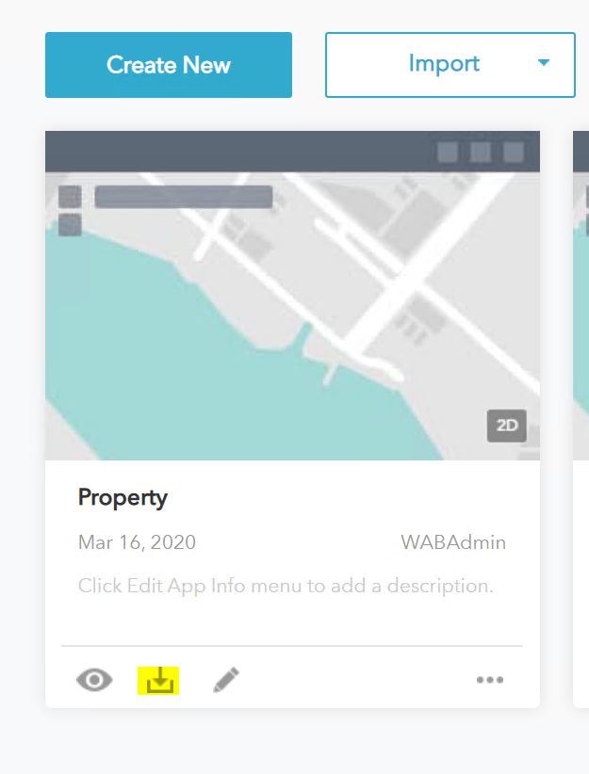

* + 1. Close that instance of WAB and open the latest one that you want to migrate the apps to. Import from Computer, and point to the downloaded apps (they should still be zipped). Import the apps one at a time.

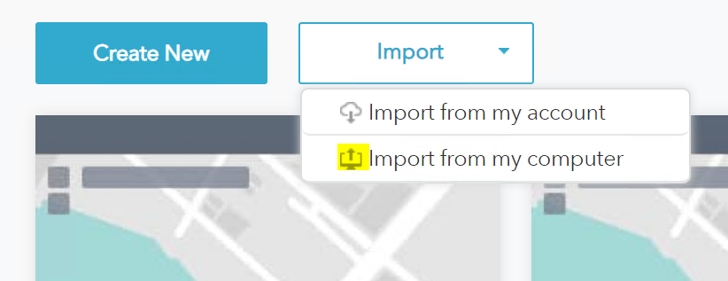

Notes

The Waahi release name should tell you the latest version of WAB against which Waahi was fully tested, for example 2.12.x.x means it was developed and tested against version 2.12 of WAB. Make sure that the version of Waahi that is being used has been tested against your version of WAB.

Some widget reconfiguration might be needed, depending on the changes in the new WAB version. We always try to highlight any reconfiguration needed in the release notes.

# Upgrade Waahi to a newer release

Follow the steps in sections 1.2 and 1.3.

If a version of Waahi has been deployed previously, files will be overwritten when the deployment app is run as needed with the version that was downloaded.